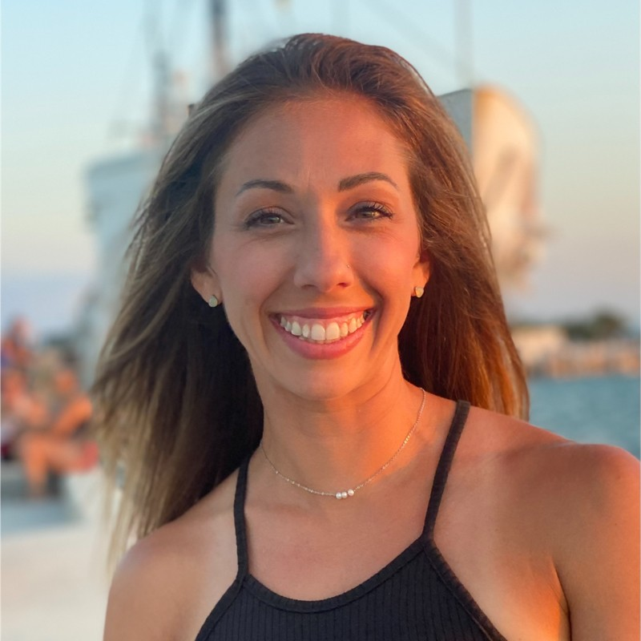 |  |  |  | Kimberly Kate  Jakushev
12/01/2022
To Whom It May Concern
XDR Radiology Recruiter
XDR Radiology

Sales Support Specialist
I am excited to apply for the position of Sales Support Specialist at XDR Radiology. I've been a Certified Radiologic/Computed Tomography Technologist for over 10 years, and I'm passionate about medical technology, digital solutions and patient care. When I read the listing for this role, I was excited to see how well I meet the requirements and the way your organization's mission matches my professional goals.
In my experience as a Radiologic Technologist with HCA Healthcare, I gained years of experience in the industry including working as the super user of GE Digital X-Ray Machine and have operated the GE 64 Slice CT Scanner as well as other imaging solutions. I am now looking to leverage my experience and transition into a sales role within the Healthcare space. I have my A.S. Degree in Radiology and I am actively pursuing my Batchelor’s in Finance with Western Carolina University, I am a fast learner and great with building relationships within the Healthcare industry. I believe my education and real-world experience as a Radiologic Technologist will help me success with XDR Radiology. I appreciate your consideration and hope to be able to discuss how I can aid in XDR Radiology businesses growth.
Sincerely,
Kimberly Kate Jakushev
192 West Main St.
Franklin, NC 28734
 |  | 828.421.2093
 |  | kjakushev@gmail.com
 |  | www.linkedin.com/in/kimberly-jakushev

Kimberly Kate Jakushev
192 West Blvd, Franklin, NC 28734 | C: 828.421.2093| kjakushev@gmail.com
Radiologic Technologist ARRT RT(R) (CT)
Certified Radiologic & Computed Tomography Technologist with over 10 years’ experience in a fast-paced environment providing quality patient care and safety. Motivated fast learner with great interpersonal skills and very energetic. Has a positive track record with working with others in a team environment and have an outstanding work ethic.
Key Skills include:
- 10 years’ experience in operating GE Digital X-Ray Machine and GE 64 Slice CT Scanner  - Radiology Imaging IT experience including Post Processing imaging experience  - Deep understanding of Healthcare IT landscape  - Objectively evaluate information and make appropriate decisions | - Communicate effectively both orally and in writing with Executives and healthcare providers.  - Time Management/Conflict Resolution  - Expert in medical documentation/compliance  - Highly skilled in maintain complex Medical Order/Task list under strict deadlines serving multiple providers
Experience
Radiologic Technologist/Medical Assistant  HCA Healthcare – Franklin, North Carolina | Sept 2013 – Present
Perform imaging procedures, document medical information, remove sutures/staples and draw injections. Perform imaging procedures, fluoroscopic and OR exams. Cross sectional exams including angio studies.
Duties include, but are not limited to the following:
- Prepare patients for radiologic procedures with detailed instructions. Ensuring patients safety and comfort during the exam.
- Ensures operation of radiology equipment by completing preventive maintenance requirements, following manufacturer’s instructions, troubleshooting malfunctions, calling for repairs, maintaining equipment inventories, and evaluating new equipment and techniques.
- Complies with federal, state, and local legal and professional requirements by studying existing and new legislation; anticipating future legislation; enforcing adherence to requirements; and advising management on needed actions.
- Maintains professional and technical knowledge by attending educational workshops, reviewing professional publications, establishing personal networks, and participating in professional societies.
- Prepares patient for radiological procedure by positioning patient, adjusting immobilization devices, moving equipment into a specified position, and adjusting equipment controls to set exposure factors.
- Maintains production and quality of radiographs by following established standards and procedures, developing radiographs, observing radiographic results, and making necessary adjustments.
- Documents patient care services by charting in patient and department records.
- Maintain radiology supplies inventory by checking stock, anticipating future needs and placing orders
- Perform related administrative duties including completing necessary forms, labeling films and film envelopes and maintaining procedure logs.
Office Manager  Roto-Rooter Plumbers – Franklin, North Carolina | Aug 2010 – Mar 2014
Executed accounts receivable and payable. Answer phones and scheduled appointments. Completed payroll weekly and handled monetary transactions.

Education & Training
Associate of Applied Science: Radiology 2012
Southwestern Community College—Sylva, NC 28779
Member of National Technical Honor Society, Treasurer and Member of the Latent Image Club, 3.895 GPA

* Currently enrolled at Southwestern Community College with the intention to transfer to Western Carolina University to obtain a Batchelor Degree in Finance

Certifications
BLS-Basic Life support ARRT RT(R) (CT)

References provided upon request

